**BLUECITY-ATMEGA_BOX PIN REFERENCE**

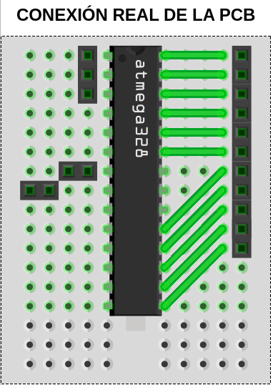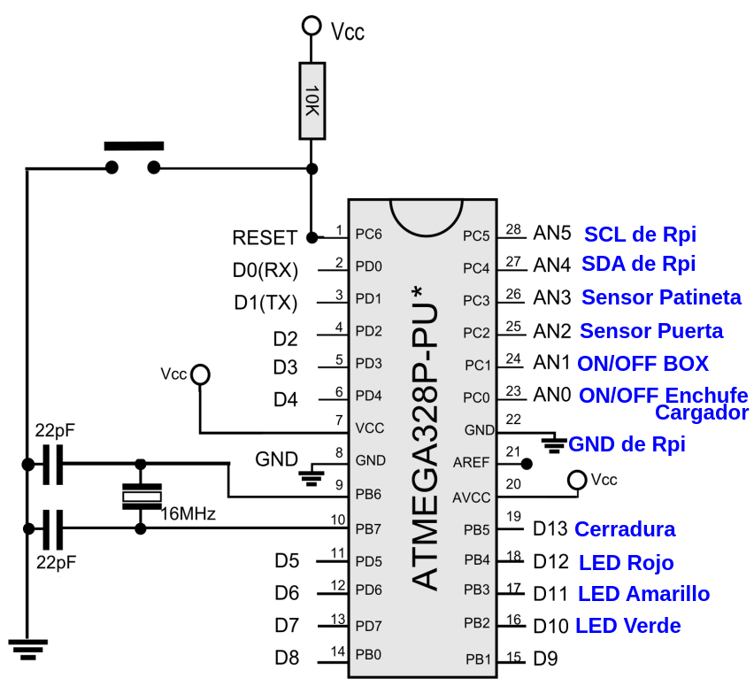

| **ATMEGA_BOX PIN REFERENCE** | | |
| --- | --- | --- |
| **DE: PIN ATMEGA** | **A: SENSOR** | **A: ACTUADOR** |
| **A5** |  | SCL de Raspberry |
| **A4** |  | SDA de Raspberry |
| **A3** | Sensor Patineta |  |
| **A2** | Sensor Puerta |  |
| **A1** |  | Relé ON/OFF BOX |
| **A0** |  | Relé Cargador del BOX |
| **13** |  | Relé Cerradura |
| **12** |  | Relé LED Rojo |
| **11** |  | Relé LED Amarillo |
| **10** |  | Relé LED Verde |
| **9** |  | Servo Cerradura(test) |